## *Summary*

In a fictionalized version of a Medieval Dark Fantasy Europe in the Kingdom of Bohemia was a weak king named Germaihn. The kingdom was small and was constantly under attack from northern barbarians and other forces. An ambitious and young individual of the time who had made a name for himself as a great warrior known as ***Barbarossa*** of the band of the Radiant Sun conquested easily over Germaihn’s forces and quickly rose to the position of King. He ruled for many years and grew the kingdom immensely as a dominant but unifying force. But grew distant overtime from his people and his royal advisors. Secluding to his studies, he heard of an abandoned prison on the corner of his grown kingdom that travelers had been talking about recently that intrigued him and made a visit. What he found was so enticing that he further became secluded in his studies, rejecting his royal responsibilities. The people became concerned for the well-being of their country and their beloved king. One day he disappears with rumors that he went back to the dungeon by himself. A bounty goes out for without their king this now great country will surely fall apart with the threat of surrounding kingdoms. The player plays as a variety of classes, all of which have their own personal reasons for wanting to visit the dungeon and interact with the King. Many other NPCs throughout the various kingdoms of this medieval Europa land are also there to aid or… not quite aid the player in this grand mission. Consider that the dungeon is a former prison but its inhabitants, the guards, other workers, prisoners, never did leave. Their fates have yet to be confirmed, maybe some are still out there to help the player *or not*. As the Dungeon goes down we start to abandon the idea of it being a place lived in and rather a place corrupted and maliciously twisted. Contorting space and time, the player may have to travel through abstract areas that may explain more of this corruptive void that has enveloped the dungeon. Maybe these secrets of this corruptive void are precisely why the King had a fascination in this place.

Each one of the [characters](https://docs.google.com/document/u/0/d/1YxFS7oqt7DW3lX-1MbuP4sY-uXh9HnmY5Q52fdS1rDk/edit) the player can pick has a different reason for coming to this dungeon. But it's all centered around this great man of high renowned of the time known as Barbarossa, this man is essentially Alexander the Great who took over a lot of this medieval world the game takes in but developed a deep fascination for these dungeons, he headed in alone a while ago and hasn't come out so there is a bounty for him, some characters want to kill him themselves for what he did to their home countries, or some are fascinated witBarbarossasa’s desire for this strange place.

Initial story will be mostly communicated to the player at first through [opening character choices,](https://docs.google.com/document/u/0/d/1YxFS7oqt7DW3lX-1MbuP4sY-uXh9HnmY5Q52fdS1rDk/edit) NPC interactions, environmental storytelling, and item descriptions.

(Example down below with additional lore and actors in the story)

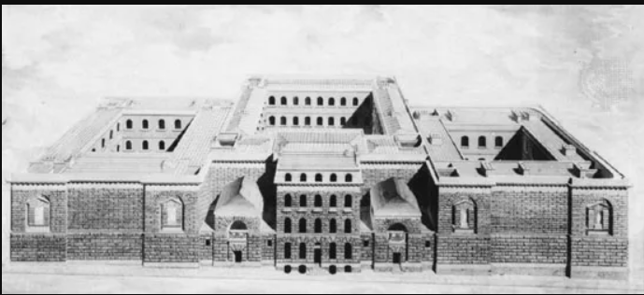

Newgate Prison England^

Reference for Dungeon Level 1

Safe areas for Level 1 will be the courtyards to the left and right sides where players can ‘clear’ enemies off and permanently be safe areas where you can find NPCs in the world and send them to. Center courtyard will need to be unlocked through complete exploration of level 1, need to clear center courtyard and beat boss to go further into the dungeon.

NPC List

—---- Currency is the same for merchants and leveling player character—-----------

Merchant NPC - Heals, Mana, keys (for shortcuts probs not progression), other utility items

Teacher NPC - Can teach skills if acquire a certain item (Rare chests, mini boss drops, boss drops)

Smith NPC - Using currency and upgrade items to upgrade favorite items for big damage

Lore NPC - Flavor text person // world building

Questline NPC - Offers player a choice to aid character in their mission, will benefit player with items, or assistance in a boss fight

Training Dummy NPC - Player can fight a training dummy to test new items, see damage numbers

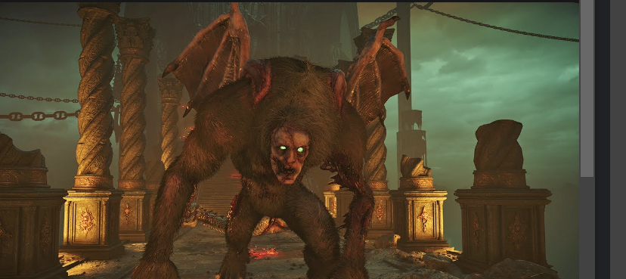

Potential Reference for Boss 1 ‘Maneater Demon Souls’

Some sort of above average toughness enemy, high damage, high hp, weak to aspects of environment that player can utilize (i.e. weak to fire, ‘oh there are torches that I can make him walk into so he’s stunned for a sec’)



Potential Reference for Boss 2 ‘The Bound Sorcerer’

A once-powerful sorcerer, now twisted by corruption. They seek to regain their former glory by consuming the life force of dungeon intruders. Casts dark magic projectiles, summons shadowy minions (i.e. dark versions of the Beastmaster or Summoner’s pets), and creates zones of corruption that deal DOT to the player. Players need to dodge projectiles, quickly eliminate minions, and stay out of the corruption zones and then damage the sorcerer when he’s recharging his power. He is the only enemy weak to poison, since he is human. This boss has very high damage and low health.

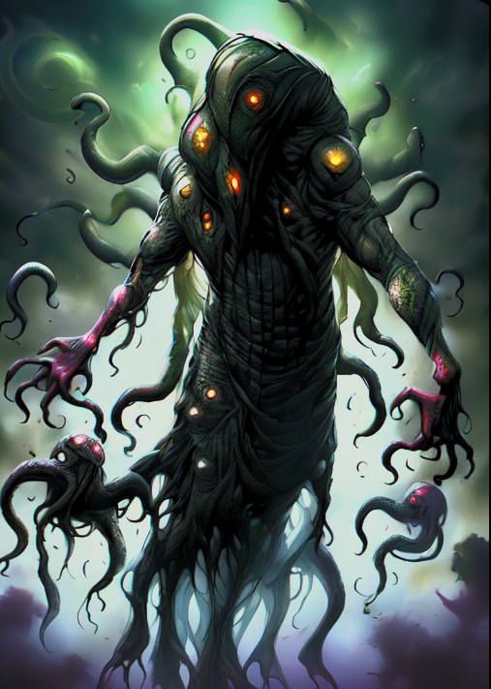

Potential Reference for Boss 3 ‘The Corruptor’

The source of the dungeon’s corruption, a being that seeks to expand its influence beyond the dungeon walls. A formless mask of dark energy that occasionally takes a vaguely humanoid shape, with tendrils of corruption extending into the surrounding area. This boss shifts the battlefield by creating tendrils that must be avoided, launches bursts of dark energy, spawn in basic enemies, and can temporarily envelop itself in a shield of corruption. Players need to target weak points that appear on The Corruptor’s body to break its shield before dealing damage. This boss is relatively large with high health and damage, and it is only weak to holy damage.

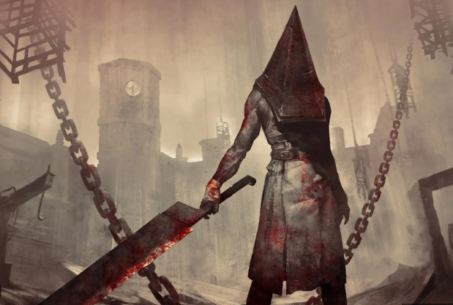

A ‘little’ incentive for the player to progress hastily or at least not experience farm

Lesser Enemies drop reduced XP when they respawn after player rest for this reason

As you go down the Dungeon unknown, archaic forces have distorted space and time as the dungeon morphs into something else

Level 2 Mossy further ruined heavily aged deteriorated, shows the distortion of time as prison was only abandoned in recent years

Level 3 Flooded Mines area, ‘Drowned from Minecraft’ and ‘Drowner from Witcher’ type enemies, etc…

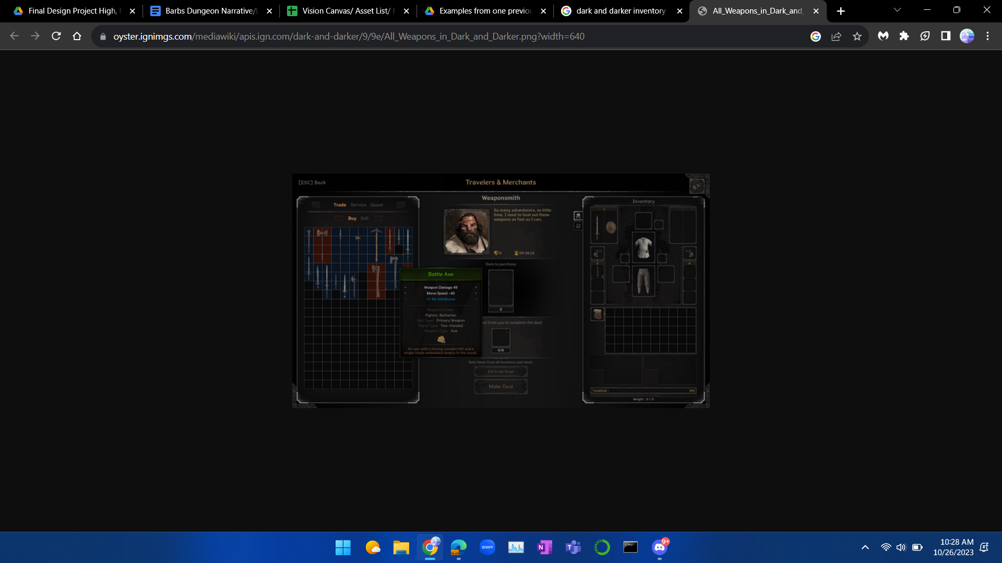

Inventory Reference

Ranger - Character Lore and Concept of opening dialogue and choices

* ‘You came from a family of no renown, every day was difficult surviving, and caring for your younger siblings. Your parents weren’t around so it was up to you to provide no matter the cost.’
* Option 1: Rogue (Shadow Strike, Poison Dart)
* Option 2: Archer (Piercing Shot, Volley)
* Option 3: Beastmaster (Feral Charge, Primal Howl)
* You started to build a reputation in your small village in the kingdom of Bohemia. But still struggling to earn a living, you heard about the news of some foolish king. You’ve always tried to capitalize off any situation you can. You leave your village to pursue this opportunity. What weapon do you tow?
  + Option 1: Bow
  + Option 2: Daggers
* Before you enter the dungeon, you stop by a neighboring village and stock up on goods.
  + Option 1: Health Potions
  + Option 2: Armor
  + Option 3: Bomb

Knight - Character Lore and Concept of opening dialogue and choices

You grew up in the kingdom of Bohemia, you remember the rise and fall of King Germaihn. But he was nothing compared to the larger the life figure that was Barbarossa. Once a young mercenary, he rose to power through sheer determination and ambition. Overthrowing Germaihn, Barbarossa ruled Bohemia for many years and you had always looked up to him. You wanted to serve your king so you entered the infantry and excelled at the top of your class, you got to choose what role you would fill in Barbarossa’s army.

* Option 1: Paladin (Enchanting Weapon, Lesser Heal)
* Option 2: Berserker (Frenzy, Berserker’s Rage)
* Option 3: Commanding General (Commanding Shout, Knight’s Loyalty)

The king grew distant from his kingdom and you had gone up the ranks to be a royal guard. All you wanted was to make him happy, but he was always far away in his studies. This passivity started to enrage the kingdom, and made bordering kingdoms curious. With this downtime you would learn of the kingdom’s religion. Though faith was foreign to you, you were able to pick a little bit of it up.

* Option 1: Lesser Heal
* Option 2: Enchantment
  + Enchant’s Weapon with holy magic

Eventually the king disappeared and when searches had been conducted in his chambers it came across only one possible location: an abandoned prison in the corner of the bohemian providence. You would go and retrieve your king at any cost. What do you stockpile on ?

Option 1: Health Potions

Option 2: Mana Potions

Option 3:Berserker Tonics

Mage/Wizard- Character Lore and Concept of opening dialogue and choices

You always had a talent for the arcane arts. But such talent can not go without upheaval, you were physically very weak. Receding into your studies for many years made you become very distant from mankind. But there’s only so much knowledge for a singular mind to obtain. What do you decide to focus your time on?

* Option 1: Divine Channeler (Enchanting Weapon, Lesser Heal)
* Option 2: Chaos Sorcerer (Fireball, Chain Lightning)
* Option 3: Summoner (Lesser Conjured Bow, Lesser Conjured Shortsword)

Your talents attract the kingdom of Bohemia and their ambitious King Barbarossa. You became his royal advisor only a few years into his reign. The king was always glowing with his visions for what he wanted his kingdom to become. You saw through this as only the foolishness of youth. As you continued the King's advice, he grew more and more corrupted by the knowledge in the Kingdom's great library. He went against your better judgment and started reading about sightings of corruption oozing out of an abandoned prison, a relic of the past. You had been in the kingdom for so long you became enticed by the faith of the kingdom, do you further learn these studies or take this time to learn other sorcery?

* Option 1:Learn the other sorcery from the previous option?
* Option 2: Learn advance faith,
  + (Greater Healing, Faith magic super effective against undead)

The king had disappeared after a time, not surprising to you. Though you recognize the foolishness of this king’s ambition, you have grown close in your decade of advising him. You also wonder about this enlightenment he pursues and the mysteries of the Dungeon. You take up arms and pursue your king, what do you bring?

Option 1:Mana Potions

Option 2:Health Potions

Option 3: Arcane shield

Assassin Character Lore and Concept of opening dialogue and choices

Veiled in shadows, your existence is a whispered legend. A ghost in the alleyways, you’ve learned to survive where others fear to treat.

* Option 1: Shadowblade (Silent Strike, Smoke Bomb)
* Option 2: Swiftstrike (Dash Stab, Momentum Shift)
* Option 3: Venomancer (Venomous Blade, Infiltrate)